Physics 30 Lesson 18 Electric Current

The electrochemical cell
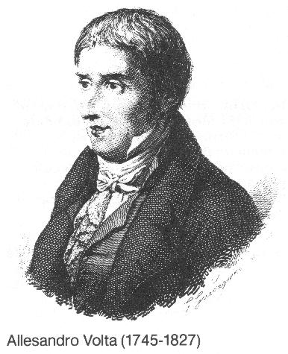
Count Allessandro Volta (1745 - 1827) was an Italian scientist who designed the first electrochemical cell. An electrochemical cell is one in which a spontaneous chemical reaction produces electrical energy. Volta’s cell was the first to produce a steady flow of electric current. Until his discovery, all electrical experiments used electrostatic charges produced by friction. Since the static discharge happened very quickly experiments were difficult to perform. Volta’s discovery was immediately recognized as a major break-through by other scientists.

The charge build up at the electrodes of an electrochemical cell create a potential difference between the electrodes. The external cathode (negative pole) on a cell is the anode inside the cell. The internal anode accumulates electrons from the chemical reaction. Anions (negatively charged ions) travel to the anode where they release their electrons. The external anode (positive pole) on a cell is the cathode inside the cell. The internal cathode gives electrons away in the chemical reaction. Cations (positively charged ions) travel to the cathode where they collect electrons.
−

+
+

−
cell
external wire
external anode
internal cathode
external cathode
internal anode

The chemical reaction will continue only if the external cathode (internal anode) gives away the excess electrons it is gathering in the cell, while the external anode (internal cathode) must replenish its supply of electrons. In other words, an external wire is required to complete the electric circuit. Without the wire nothing happens. If a conductor is connected from the external cathode to the external anode, electrons will move through the conductor and the chemical reaction in the cell will continue. Since the flow is caused by the potential difference between the external cathode and the external anode it is believed that the potential difference forces the electrons through the conductor. Thus, potential difference has incorrectly inherited the name electromotive force (EMF) because it forces electrons through the conductor. However, the term EMF is still in use. The terms potential difference and EMF can be used interchangeably. (For those who are also studying Chemistry 30, in physics our study focuses on the external circuit connecting the external cathode to the external anode. In chemistry, the focus is on what happens in the internal circuit where ions flow to the internal cathode and anode.)

Current Flow
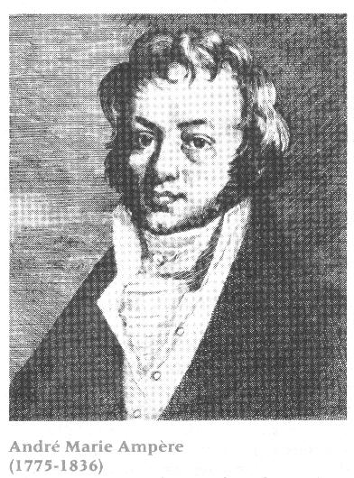
Refer to Pearson pages 602 and 603.

Andres Ampere (1775 – 1836) quickly made use of Volta’s cell to study the flow of charge through a conductor. The study of electricity changed from investigating static electricity to investigating current (flowing) electricity.
Ampere gave an operational definition for current flow (recall that an operational definition is based on observation, not on theory):

When a Coulomb (C) of charge flows past a given point in a conductor over a one second time interval, a current of one Ampere (1A) exists.

where I current (A) [1 ampere = 1 A = 1 C / s]
q charge (C)
t time (s)

If 1.2 x 10²⁰ electrons flow past a given point in a conductor over 2.0 seconds, what is the current?

Resistance
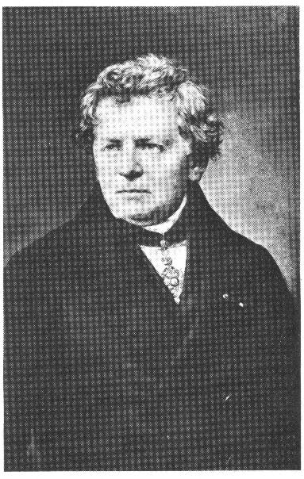
George Simon Ohm (1787 – 1854) is responsible for the early study of conductivity of substances. He found that some substances made better conductors than others. At this point, it may be prudent to review the difference between conductors and insulators. Electric charges move through and spread over objects. A conductor is a material through which electric charges move easily. Good conductors are items such as any metal (copper & silver), any ionic solution (dissociated into ions by the solvent) or hot gases. An insulator is any material that retards or restricts the flow of electric charge. Insulators include such items as glass, dry fibers, or dry air. However, if the potential difference across the conductor is large enough, all materials, including insulators, will conduct electricity.

Ohm found it easier to compare substances in terms of their reluctance to allow the flow of electric charge. He called the factor resistance and it is inversely related to conductivity. Ohm found that the resistance of substances was related to several factors:
- The type of material. Each substance has a resistance value that is innate to the material.
- Resistance is directly proportional to the length of the conductor. The longer the conductor, the greater the resistance. That is why the City of Calgary asks residents to use short cords to plug their cars in during the winter.
- Resistance is inversely proportional to the cross sectional area of the conductor. The more area, the greater the flow of current. Like a water hose, a large diameter water hose will move more water than a small diameter hose.
- Resistance is generally directly proportional to the absolute temperature of the conductor. As the temperature increases, the resistance increases.

Resistance ∝ material x absolute temperature x length
cross sectional area

Resistance is measured in Ohms ( ).

Ohm’s Law
Ohm is remembered for the simple relationship known as Ohm’s Law which is:

where I current (A)
V potential difference (V)
R resistance (Ω)

A 6.0 volt source is applied across a conductor with a resistance of 4.0 Ω. What is the current flow through the conductor?

A 5.4 mA current is measured across a 470 Ω resistor. What is the potential drop across the resistor?
The limitations of Ohm’s Law are:
- It applies only to solid conductors. It cannot be used, for example, to calculate current flow through a salt solution.
- Since resistance varies with temperature, Ohm’s law will vary with temperature.
- It applies to direct current and instantaneous alternating current.
- Some combinations of materials conduct charge better in one direction than in the other. Ohm’s law does not account for this situation.

The direction of electric current
Early in the nineteenth century, Benjamin Franklin made the assumption that there were two electrical states: one with more than the normal amount of electricity, which he called a positive charge, and one with less than the normal amount of electricity, which he called a negative charge.

Electric current was defined as the rate of movement of electrically charged particles past a point, so it was only natural to assume that the charge moved from an area where there was an excess (positive charge) to an area where there was a deficit (negative charge). Thus, the direction of the electric current was defined as moving from the positive terminal to the negative terminal of the source of electric potential. This assumption about the direction of the electric current is called "conventional current".
+
−
conventional current

resistor

Much later, after the conventional current assumption had become firmly entrenched in scientific literature, the electron was discovered. It soon became clear that what actually constituted an electric current in a solid conductor (such as a wire) was a flow of negatively charged electrons from the negative terminal to the positive terminal of the source of electric potential. This model, favored by many physicists since it gives a more accurate representation of what is actually happening in the circuit, is called "electron current” flow. The same circuit, using electron current, would appear as:
electron flow
−
+

It should be noted that the term "current" will be used to denote the magnitude of the rate of charge flow. For example, a current of ten amperes can refer to an electron flow rate of ten coulombs per second or a conventional current of 10 coulombs per second.

Hand-in Assignment
1. Calculate the amount of current through an electric toaster if it takes 900 C of charge to toast two slices of bread in 1.5 min. (10 A)

2. A light bulb with a current of 0.80 A is left burning for 20 min. How much electric charge passes through the filament of the bulb? (9.6 x 10² C)

3. A gold-leaf electroscope with 1.25 x 10¹⁰ excess electrons is grounded and discharges completely in 0.50 s. Calculate the average current through the grounding wire. (4.0 x 10⁻⁹ A)

4. A small electric motor draws a current of 0.40 A. How long will it take for 8.0 C of charge to pass through it? (20s)

5. How many electrons pass through a light bulb in each second if the bulb has a current of 0.50 A through it? (3.1 x 10¹⁸)

6. A portable radio is connected to a 9.0 V battery and draws a current of 25 mA. What is the resistance of the radio? (3.6 x 10² Ω)

7. An electric clothes dryer is connected to a 230 V source of electric potential. If it has a resistance of 9.2 Ω, calculate the current it draws. (25 A)

8. A large tube in a television set has a resistance of 5.0 x 10⁴ Ω and draws a current of 160 mA. What is the potential difference across the tube? (8.0 x 10³ V)

9. An electric toaster has a resistance of 12 Ω. What current will it draw from a 120 V supply? (10 A)

10. What potential difference is required to produce a current of 8.0 A in a load having a resistance of 64 Ω? (5.1 x 10² V)

11. Using a diagram of a circuit, explain conventional current and electron flow. What is the difference between "conventional current" and "electron flow "?

Activity – Ohm’s Law
Problem:
Find the resistance of a resistor using Ohm's law.

Materials:
low-voltage DC power supply
two different resistors (130 Ω, 220 Ω)
DC ammeter
DC voltmeter
various connecting wires

Procedure:

1. Each wooden block is labelled with the value of the resistor. This will be your theoretical value for resistance.

2. Set up the series circuit shown in the diagram using one of the resistors. Do not turn the power on until the circuit has been checked by your teacher.
V
A
Use the 15 V scale
Use the 50 mA scale
Power supply
Resistor

3. Switch the power supply to the lowest setting. Measure the current on the ammeter (note the unit for current). Record the measurements in a suitable data table. Turn the power supply knob to the next setting. Measure and record the potential difference and the current. Repeat this procedure until you have gone through all the settings on the power supply.

4. Repeat step 3 for the second resistor.

5. Plot a graph such that the slope will equal the resistance of the resistor. Plot both graphs on the same sheet of graph paper using a different colour for each one. Calculate the resistance of each resistor. Show all calculations.

6. Calculate the percentage of error between the graphical value and the given value.

7. When looking at the graph, how can you tell which resistor has the highest resistance? Explain.

